[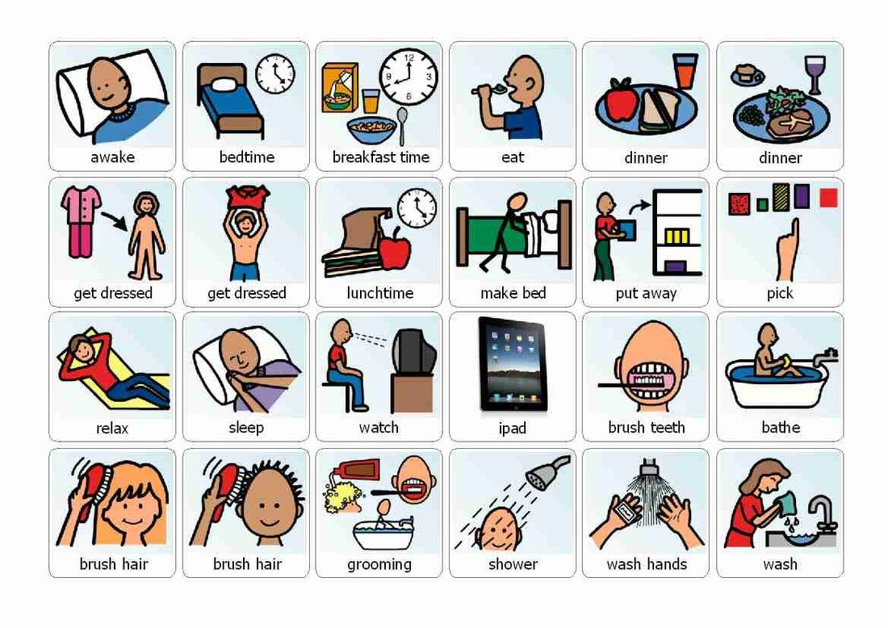](https://www.google.com/url?sa=i&rct=j&q=&esrc=s&source=images&cd=&cad=rja&uact=8&ved=2ahUKEwjbzMG736joAhXQ3oUKHQ4HCioQjRx6BAgBEAQ&url=https://www.pinterest.com/pin/509751251549281046/&psig=AOvVaw0uAbIUCtmj3xksrmxo73Mc&ust=1584782578654565)

[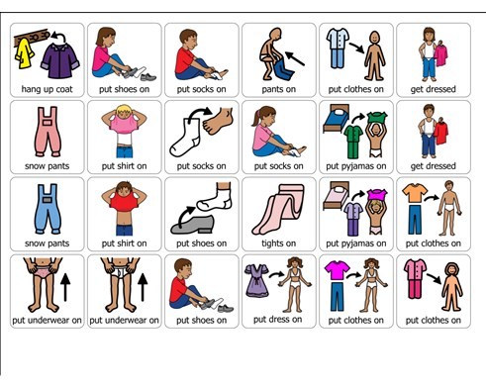](https://www.google.com/url?sa=i&rct=j&q=&esrc=s&source=images&cd=&cad=rja&uact=8&ved=2ahUKEwiOnrXb36joAhUDz4UKHQwUCiEQjRx6BAgBEAQ&url=https://boardmakeronline.com/Activity/12446276&psig=AOvVaw0uAbIUCtmj3xksrmxo73Mc&ust=1584782578654565)[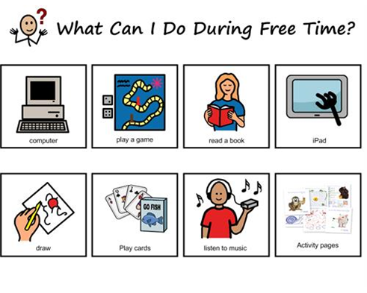](https://www.google.com/url?sa=i&rct=j&q=&esrc=s&source=images&cd=&cad=rja&uact=8&ved=2ahUKEwiFisTi4KjoAhUnx4UKHb_hCEIQjRx6BAgBEAQ&url=https://boardmakeronline.com/Activity/2160961&psig=AOvVaw076_tgtJpMU-sC46_OujJN&ust=1584783442816857)

[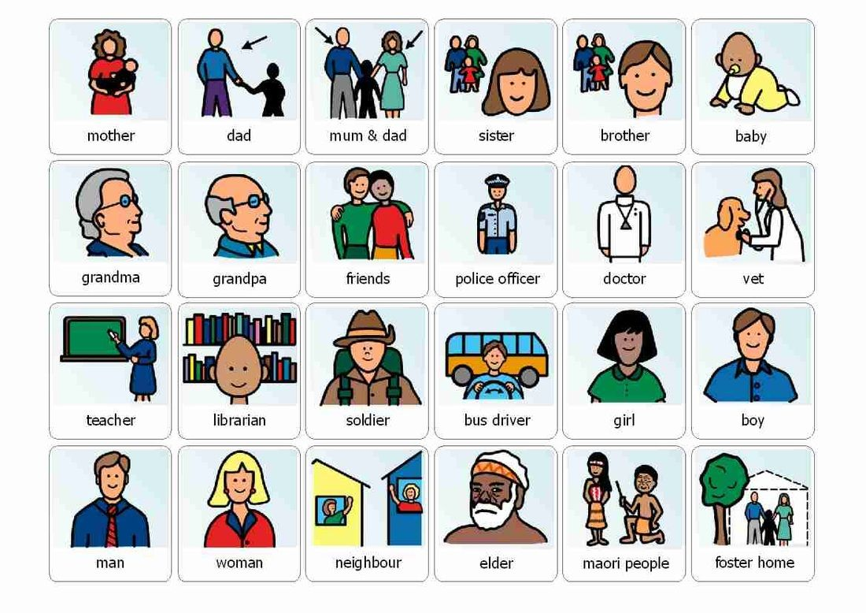](https://www.google.com/url?sa=i&rct=j&q=&esrc=s&source=images&cd=&cad=rja&uact=8&ved=2ahUKEwjok7Pm4ajoAhVtxoUKHSvADTIQjRx6BAgBEAQ&url=https://www.pinterest.nz/pin/490329478158249183/&psig=AOvVaw076_tgtJpMU-sC46_OujJN&ust=1584783442816857)

[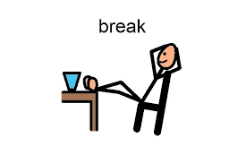](https://www.google.com/url?sa=i&rct=j&q=&esrc=s&source=images&cd=&ved=2ahUKEwjC5cSm4qjoAhUny4UKHWGrBpAQjRx6BAgBEAQ&url=http://www.autismcircuit.net/tool/break-card&psig=AOvVaw076_tgtJpMU-sC46_OujJN&ust=1584783442816857)

[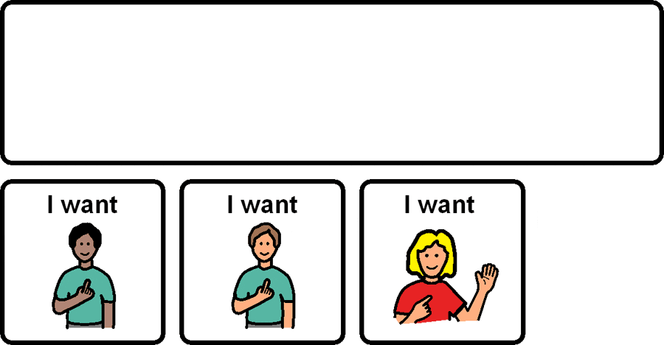](https://www.google.com/url?sa=i&rct=j&q=&esrc=s&source=images&cd=&ved=2ahUKEwj7rebF5KjoAhUE6RoKHamwDaIQjRx6BAgBEAQ&url=https://visuals.autism.net/&psig=AOvVaw076_tgtJpMU-sC46_OujJN&ust=1584783442816857)

[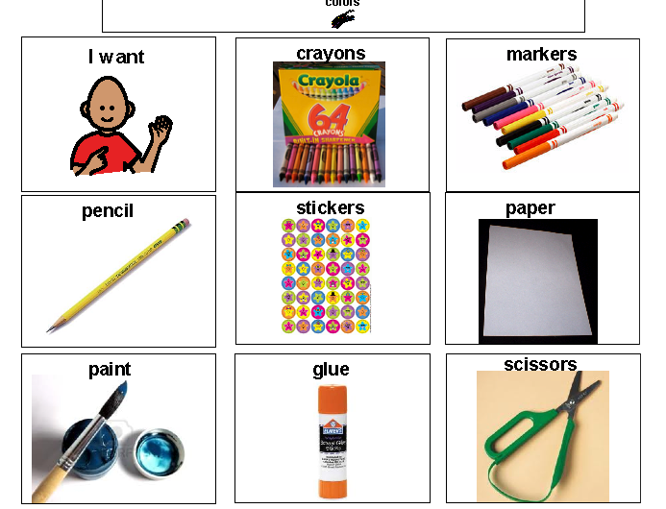](https://www.google.com/url?sa=i&rct=j&q=&esrc=s&source=images&cd=&ved=2ahUKEwjdk9z34qjoAhUBz4UKHcBUC04QjRx6BAgBEAQ&url=http://stung-treng.info/tapr/p/Pecs-Stop-Symbol/&psig=AOvVaw076_tgtJpMU-sC46_OujJN&ust=1584783442816857)

[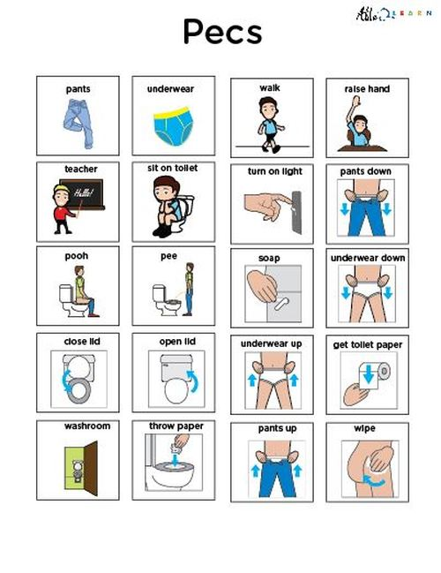](https://www.google.com/url?sa=i&rct=j&q=&esrc=s&source=images&cd=&cad=rja&uact=8&ved=2ahUKEwiDiqSn46joAhVIJBoKHeuTB2AQjRx6BAgBEAQ&url=https://able2learn.com/products/boys-community-washroom-pecs-learning-washroom-skills-pages-3.html&psig=AOvVaw076_tgtJpMU-sC46_OujJN&ust=1584783442816857)







